|  |  |  |  |  |  |  |
| --- | --- | --- | --- | --- | --- | --- |
| VILNIAUS KOLEGIJA  UNIVERSITY OF APPLIED SCIENCES  FACULTY OF ELECTRONICS AND INFORMATICS  Image result for viko logo | | |  | | | VILNIUS COLLEGE  Image result for viko logoFACULTY OF ELECTRONICS AND INFORMATICS |
|  | | |  | | |  |
| **INFORMATION SYSTEMS** | | |  | | | **INTRODUCTION TO INFORMATICS** |
| PRACTICAL ASSIGNMENT  ACTIVITY ANALYSIS OF COMPUTER SHOP ORGANIZATION  6531BX028 PI18E | | |  | | | PRACTICAL ASSIGNMENT  SPOTIFY USER MANUAL  6531BX028 PI18E |
| STUDENT | DŽIUGAS PEČIULEVIČIUS | STUDENT | | DŽIUGAS PEČIULEVIČIUS |
| (SIGNATURE)  9/30/2019 | | |  | | | LECTURER |
| LECTURER | TATJANA LIOGIENĖ | (SIGNATURE)  10/17/2018 | | VIRGILIJUS KUKLIERIUS |
| (SIGNATURE)  9/30/2019 | | |  | | | 2018 |

2019

**TABLE OF CONTENTS**

INTRODUCTION 4

A. ORGANIZATION DESCRIPTION 5

B. CONTEXT LEVEL DFD DIAGRAM 6

C. 0 (ZERO) LEVEL DFD DIAGRAM 7

D. 1 (FIRST) LEVEL DFD DIAGRAM 9

E. BOTTLENECK PROBLEM / BPMN DIAGRAM 10

F. CONCLUSIONS AND SUGGESTIONS 12

**TABLE OF FIGURES**

Figure 1 - Context level DFD diagram 6

Figure 2 - 0 level DFD diagram 7

Figure 3 - 1 level DFD diagram 8

# INTRODUCTION

**Program used for charts**

Website: draw.io

**Goal**

Create selected organizations activities description and reasonably determine the problematic field of activity.

**Tasks**

This practical work tasks are to describe organizations purpose, goals and services. Then analyze it using all levels of DFD diagrams and BPMN diagram. And then finally write a conclusion for this practical work.

# A. ORGANIZATION DESCRIPTION

**A.1.Purpose**

The purpose of an organization is to provide fully professional services at the lowest costs possible.

**A.2.Goals**

The goal is to become most popular computer and digital trade network.

**A.3.Products**

Products are computers, laptops, software, hardware, storage media.

**A.4.Services**

Provide customers a fast service. Help them in making a decision to buy a new product. Take in broken products and fix them if the warranty is valid. Sell new, “on demand” computers.

# B. CONTEXT LEVEL DFD DIAGRAM

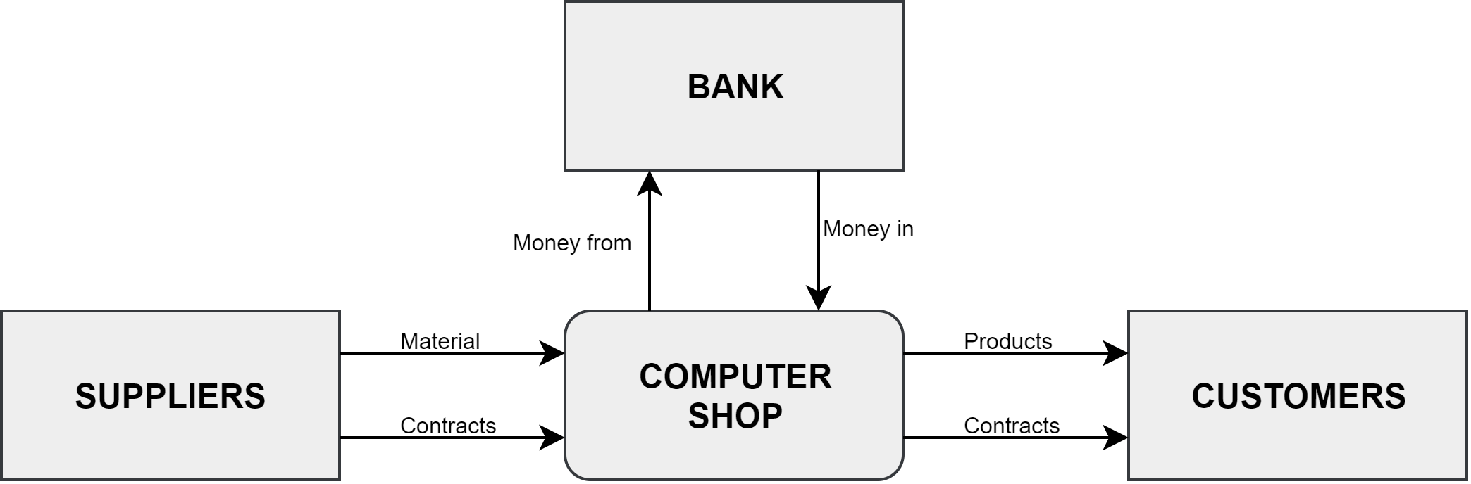

Figure 1 - Context level DFD diagram

# C. 0 (ZERO) LEVEL DFD DIAGRAM

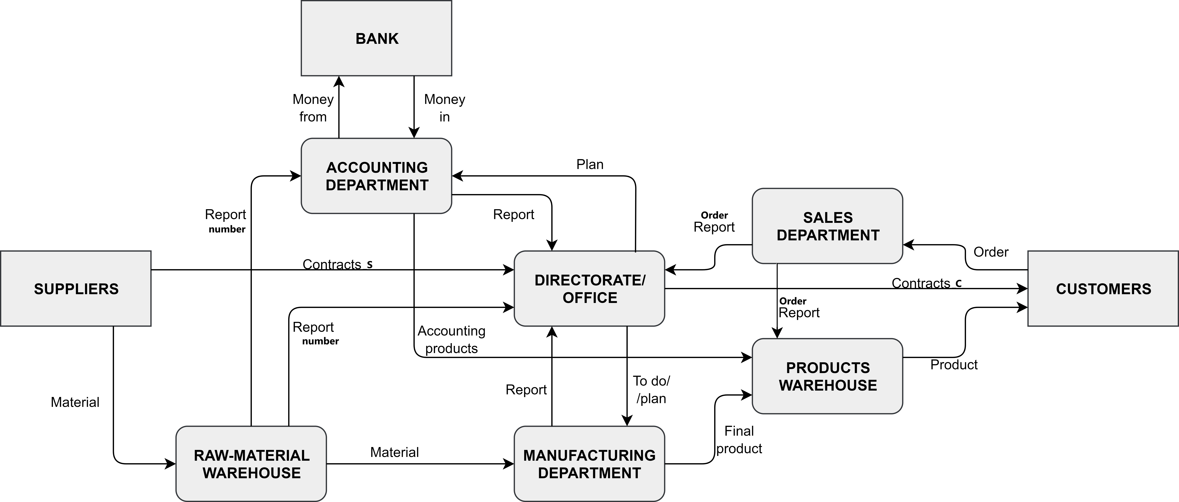

Figure 2 - 0 level DFD diagram

Table 1 - 0 level DFD process description

|  |  |
| --- | --- |
| **Process name** | **Process description** |
| ACCOUNTING | Managing company’s money. Takes it into and out of the bank. Accounting department provides office a report on how company is doing money-wise and other similar statistics.  Accounting department also takes a plan from office on what to do and report from raw-material warehouse on number of things it is stored. |
| DIRECTORATE / OFFICE | This basically is a core of a company. All managers and shareholders are here.  Office provides contracts to customers when they buy something. They also provide a plans on what to do to manufacturing and accounting departments. Office also provides suppliers with a plan on ordered things and what is needed to be sent to raw-material warehouse They take in reports form all the departments of a company. |
| RAW-MATERIAL WAREHOUSE | Warehouse where all material necessary is stored. Material is gathered from a supplier.  When needed – necessary material is transported to manufacturing department and a report is then sent to an accounting department and an office. |
| MANUFACTURING DEPARTMENT | In this department all items are assembled and when “ready to be sold”, then they are transported to product warehouse. Then a report is sent to an office. Manufacturing department takes material from raw-material warehouse and reports office about it. |
| PRODUCT WAREHOUSE | Product warehouse is where all final products ready to be sold are stored. It can be parts of computers or it can also be assembled computers from manufacturing department. Product warehouse is managed by accounting department. All products from warehouse are sent to a customer. |
| SALES DEPARTMENT | Sales department gets a number of things customers have ordered and that number of sales report goes to the office. |

# D. 1 (FIRST) LEVEL DFD DIAGRAM

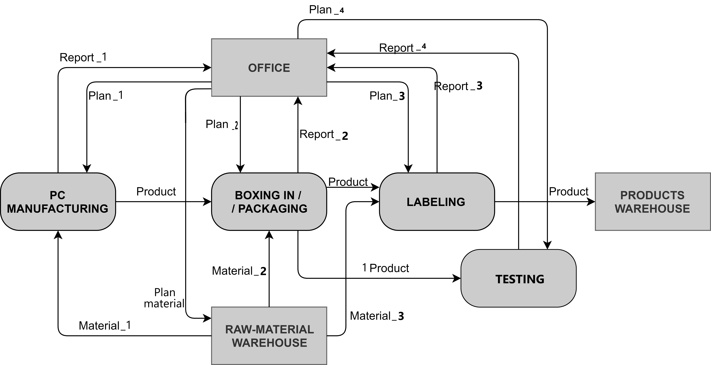

Figure 3 - 1 level DFD diagram

Table 2 -1 level DFD process description

|  |  |
| --- | --- |
| **Process name** | **Process description** |
| PC MANUFACTURING | Builds computers and computer parts from scratch. It takes all the material needed from a raw-material warehouse and also takes a plan on number of things from an office. Manufacturing department sends a report to the office on numbers of specific items received and sent. After manufacturing parts for computers, the product is sent to a packaging department. |
| BOXING-IN /  PACKAGING | Packaging department receives material from raw-material warehouse and finished products from a pc manufacturing department. All the items are packaged and sent to the labeling department. One copy of each item is sent to testing department to check if the item is good to use and has no major flaws. Packaging department also sends a report to the office on a number of material received and items sent to labeling department and testing department. |
| LABELING | Labeling department receives material from raw-material warehouse and packaged products from a packaging department. All the items are labeled and sent to the product warehouse where all items are finished and are ready to be sold. Labeling department also sends a report to the office on a number of material received and items sent to product warehouse. |
| TESTING | One copy of each item from packaging department is sent to testing department to test if the item is good to use and has no major flaws. A report for every single item is then sent to the office. Office provides testing department with a plan every time on what things to do. |

# E. BOTTLENECK PROBLEM / BPMN DIAGRAM

The bottleneck problem is that all the messages, plans and orders are sent in with all the items together. This way it can get lost and then it would be really hard to keep track of all items.



Office send a plan on how many things and items there is need to be ready and sent to be manufactured. Firstly it has to be checked if all the items in the plan are there in the warehouse. If not, then it must be ordered from the office. If everything is in stock, it has to be checked if items are needed to be packaged. If not – they’re sent to the labeling department. If items need to be packaged, then it is checked if the item is in need to be manufactured from bits, or its ready to be sold. If it is ready, the it is sent to packaging department, if not – to manufacturing.

The material which is sent to the manufacturing department is assembled and if anything is missing then the report is sent to the office, if not – then it’s checked if it needs to be packaged.

The items which need to be packaged, are sent to testing department. If item does not pass the test, then new material order is sent to the office. If everything works, then all working items are sent to the packaging department and finally packaged. All packaged items are sent to the labeling department. All items are labeled and then are sent to the product warehouse, from where the items will be reached by customers.

# F. CONCLUSIONS AND SUGGESTIONS

For the conclusions problem is that all the messages, plans and orders are sent in with all the items together. This way it can get lost and then it would be really hard to keep track of all items. To make this better, it would be a great idea to create a system where all orders and item and product numbers would be entered and kept in track.